Gaijin GDD

Subjects

* Story / Narrative
* Target Audience
* Target Platform
* Art Style
* Camera
* Control
* Character
* Enemies / Obstacles
* Abillities
* Game Progression
* Pick – ups / Upgrades
* (G)UI
* Recource Budget
* Procedural / Modular Assets
* UML Chart
* Game Map
* Reference Material

Story / Narrative

We are going for the Asian Mythology / Ninja theme.

Story:

When I was but a boy, my parents would travel to faraway lands to trade goods and spices. I went with them on their travels a I were too young to stay behind, and after months at sea we were close to our destination. But a few days away a storm arrived which broke the ship into a million pieces. How I survived I bare remember, all I know I remember is water crashing down on me as I managed to keep floating. I don’t remember how much time passed before I washed ashore.

The first I remember is opening my eyes on the floor of strange house, in a strange land with strange people speaking a strange language. This is where I met (Name), they to care of me and trained me to become a skillfull member of their clan, sworn to protect the (object). I wear this mask to hide my face, as I am an outsider. Many do not want man like me among them, and once they would find out I should fear my life.

The clan got attacked to get the (object) and it was then they found out who I truly am. Oddly enough it made them spare my life, which may be their greatest mistake yet. Driven by my anger of losing those who cared for me, and driven by the oath I took, I shall travel to the after life and seek out the strength of the dragon to avenge the (name).

Target Audience

12+ certain levels of aggression and blood, not too graphic. No curse words or sexual content.

Target Platform

Pc, met controller support and for keyboard and mouse.

Art Style

Cartoony, surreal. Ui and cutscenes based on traditional Japanese art. 3d modelled. Environment based on Japanese history/fantasy.

Camera

Eagle eye view. The camera is fixed on the player, you can’t rotate the view or adjust it in any other way. We use perspective view because that way the graphics will look better.

The camera follows the player with a smooth follow, which Wybren wrote himself, and is already up and running. Camera position relative to player can be adjusted real time.

Because we are going for an 45 degree angle on the player, we need something to stop walls or other objects from obscuring the player from the camera. This is why Wybren has written a script that fades the object in between the player and the camera (Diablo style) so the player remains visible.

Control

Twin stick shooter. Keyboard/mouse: Movement WASD. Looking/aiming: Mouse cursor. Controller: Movement: Left stick. Looking/aiming: Right stick.

The playercontroller will be built in such a way that the movement is done completely by the WASD keys. The player doesn’t have to point the mouse in the direction he is travelling. We do however want to have the character look at the mouse continualy (you control the head), and the player will walk backwards when the mouse is in the opposite direction of his movement. This allows the player to aim anywhere, whatever direction he is travelling.

Character

* Main character (western ninja)
  + Has a classic ninja suit with a red sash binded around his head, his suit is dark blue color so he is less likely to be seen. He is taller than the rest because he’s a foreigner, he has blue eyes and brown hair.

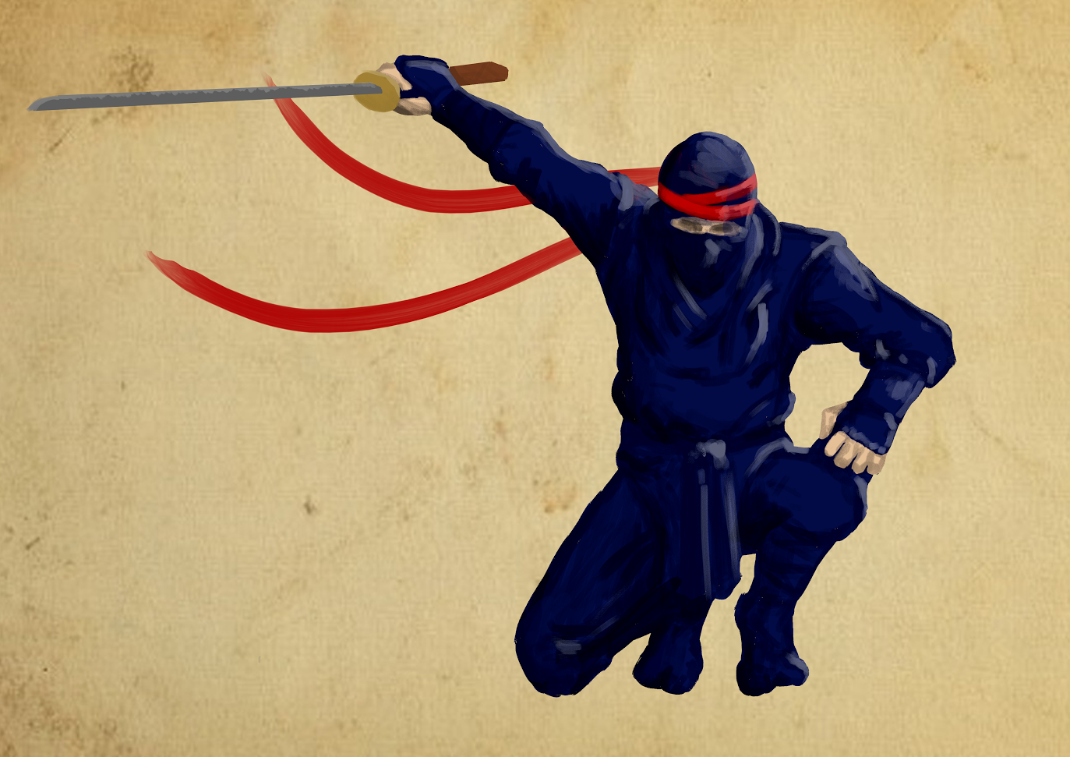

* + Concept art of Main Character.
* Clan ninja’s
  + Has the same suit but without the red sash, they’re a little bit smaller than the protagonist. They have dark brown eyes and black hair.
* Dragon
  + Blue serpent like dragon, who emits ghostly mist from its back. he has two arms with large claws

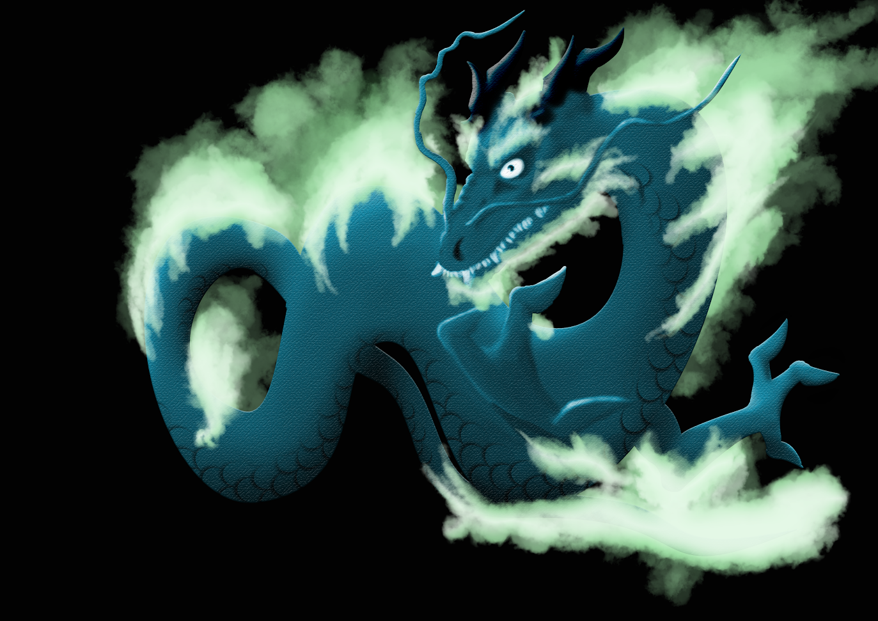

* + Dragon Concept art

* City people
  + Boring city people in light brown uninteresting clothes
* Ghost
  + A blue floating flame
* Priest
  + He’s an aged man who wears a white robe with large baggy sleeves and a square priest hat.

Enemy’s / Obstacles

* Samurai clan leader
  + Has classic warlord armor with a red oni mask. He’s very large because of the scroll and armor.
* Samurai
  + Soldier - has leather and metal plated armor. Smaller than warlord
  + Scout – has leather armor then the soldier
  + Archer – looks like scout but is equipped with a bow
  + Samurai – has classic samurai armor and is equipped with a katana
* Demons
  + Green troll like creatures with horns and permanent grins
* Puzzles

Maze: A repetitive map without too much difference in which you can get lost easily. You need to remember where you are.

Dragons riddle: The dragon gives you a riddle and you need to search the map for the object the dragon refers to.

* Bandits

Puzzles will be a scripted event, just like some enemy encounters and of course the boss fight.

AI will all work from the same script. (manager) the manager allows every detail of the AI to be tweaked. (type, ranged or melee, attack priority, speed, etc.)

Pathfinding is done with the NavMesh and NavMeshAgent.

Abilities

* Katana : Slash attack. Melee damage.
* Shiruken : Ranged damage. 10 meter range.
* Smoke bombs : Stun like effect on enemy. Enemy can’t defend or attack for 5 seconds.
* Dragon power
  + - Dragons fist: A bare handed punch that does a lot of damage and can break things like metal.
    - Dragons flight : An ability that allows you to jump 3 to 5 meters high.
    - Last resort : An ability you can use only once after casting it for a set amount of seconds. You summon the dragon spirit which can do a lot of damage.
* Sprint : Movement speed doubles for a set amount of time.
* Kusarigama : AoE of 2 meters.
* Nunchakus : Melee damage, hit attack.
* Fan : Slice weapon. Melee damage.
* Darts : Ranged damage and poison. Poison does damage for the upcoming 10 seconds. 10 meter range.

All attacks and abilities will be managed by the attackmanager. Every animation will be known in the animator for the playercharacter, and damage for every attack will be set in either an XML file or a list.

Game Progression

Scene 1 (Introduction)

Tutorial: You start in the city. Enemies attack you and you get introduced to the melee weapons: Katana, Fan, Nunchaku, Kusarigama. Enemies can be seen in a distance and you get introduced to ranged weapons: Shiruken, darts. And abilities: Smoke bombs and sprint.

Temple: Once you get to the temple an event starts where bandits attack the temple. You need to use your abilities to defeat all enemies. Once defeated you can have a dialog with the priest. Cutscene 2 starts.

Scene 2 (Spirit world)

You travel to the spirit world. Once there you have to defeat evil spirits on your quest to find the dragon, once you found him, he will give you a quest to steal something from another spirit. If you manage to get the object and hand it to the dragon it shall give you a part of his abilities. Cutscene/story part where the dragon explains the abilities you have gotten. Dragons flight which allows you to jump extra high. Dragons fist that allows you to break and damage things with your bare hand. Last resort which will summon a mist like dragon that does great damage, you can only use the ability once as it is extremely powerfull. Your spirit will find its way back to your body where you awaken to find out you have been captured while you were in the spirit world.

Scene 3 (Prison, boss fight)

You wake up in a prison where you get a tutorial of the punch skill to break free. Find your allies in the maze like prison and free them as well while now and then getting attacked by samurai. You also need to look for your weapons along the way.

After freeing your allies you go to the castle (which is on the other side of town) and jump onto the walls/roofs to find your way inside as unseen as you can. If you are spotted you need to fight the samurai (which will be too powerful for you, so combat is not an option).

Once you find the room where the warlord is the boss fight will start. You and your allies will have to fight a bunch of normal and veteran samurai that spawn before you can focus on killing the warlord. If the warlord his health is low enough you can start casting the final attack to finish him. Cutscene that sums up what happens now you’ve beaten the game.

We don’t use levels or XP or anything like that. The only time the player acquires something new, is in the second Scene (underworld), when he gets the dragon powers. These powers will allow the player to explore area’s in the city that were unreachable before he went to the underworld. Via these new area’s the player will be able to reach the castle, and trigger the bossfight.

Pick – ups / Upgrades

* Health shrines
* Dragon Abilities

(G)UI

* Start menu
  + - New game
      * Warning
    - Continue from checkpoint
    - Exit
    - Options
      * Sound
      * Music
      * Graphics

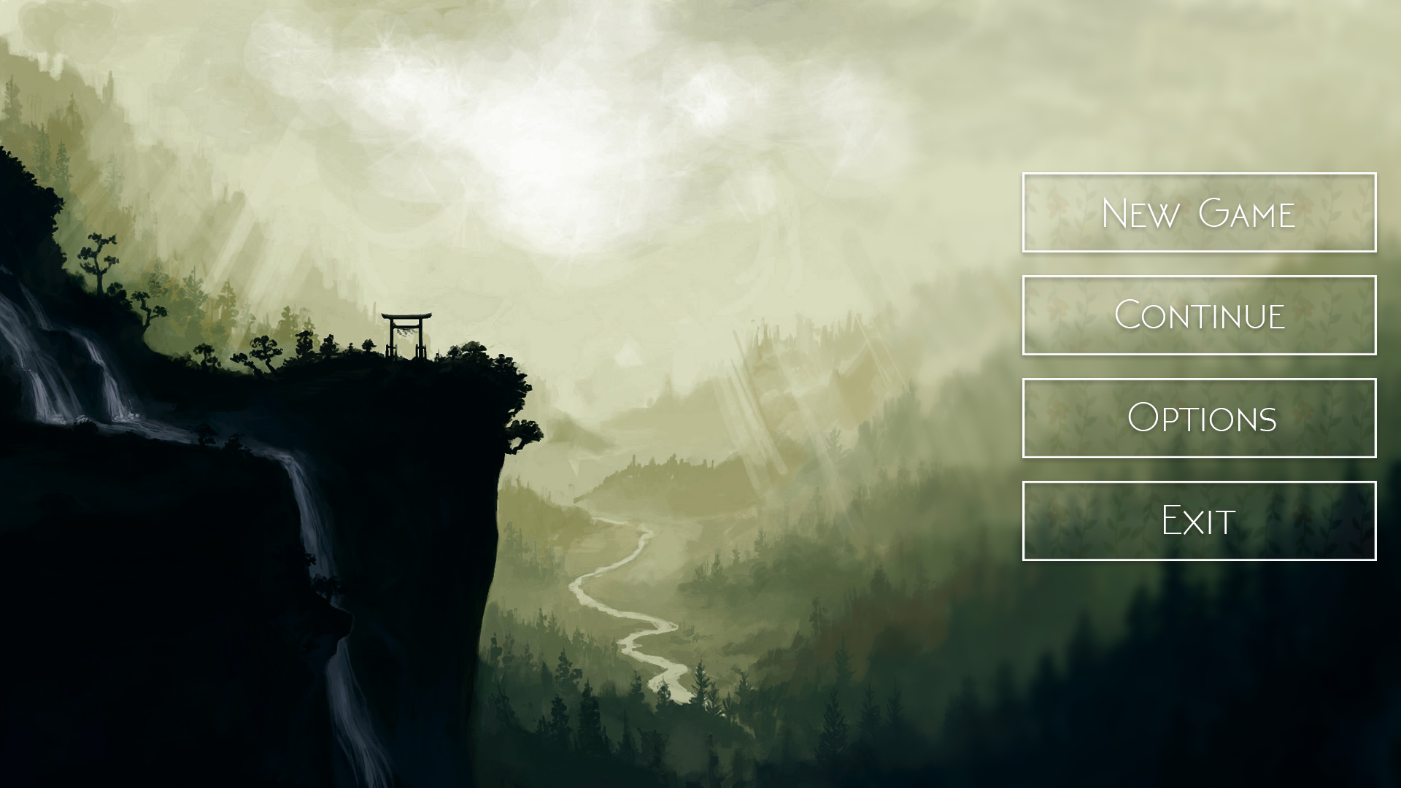

* Main menu art
* Ingame menu
  + - Back to main menu
    - Load from checkpoint
    - Options
      * Sound
      * Music
      * Graphics
    - Exit game

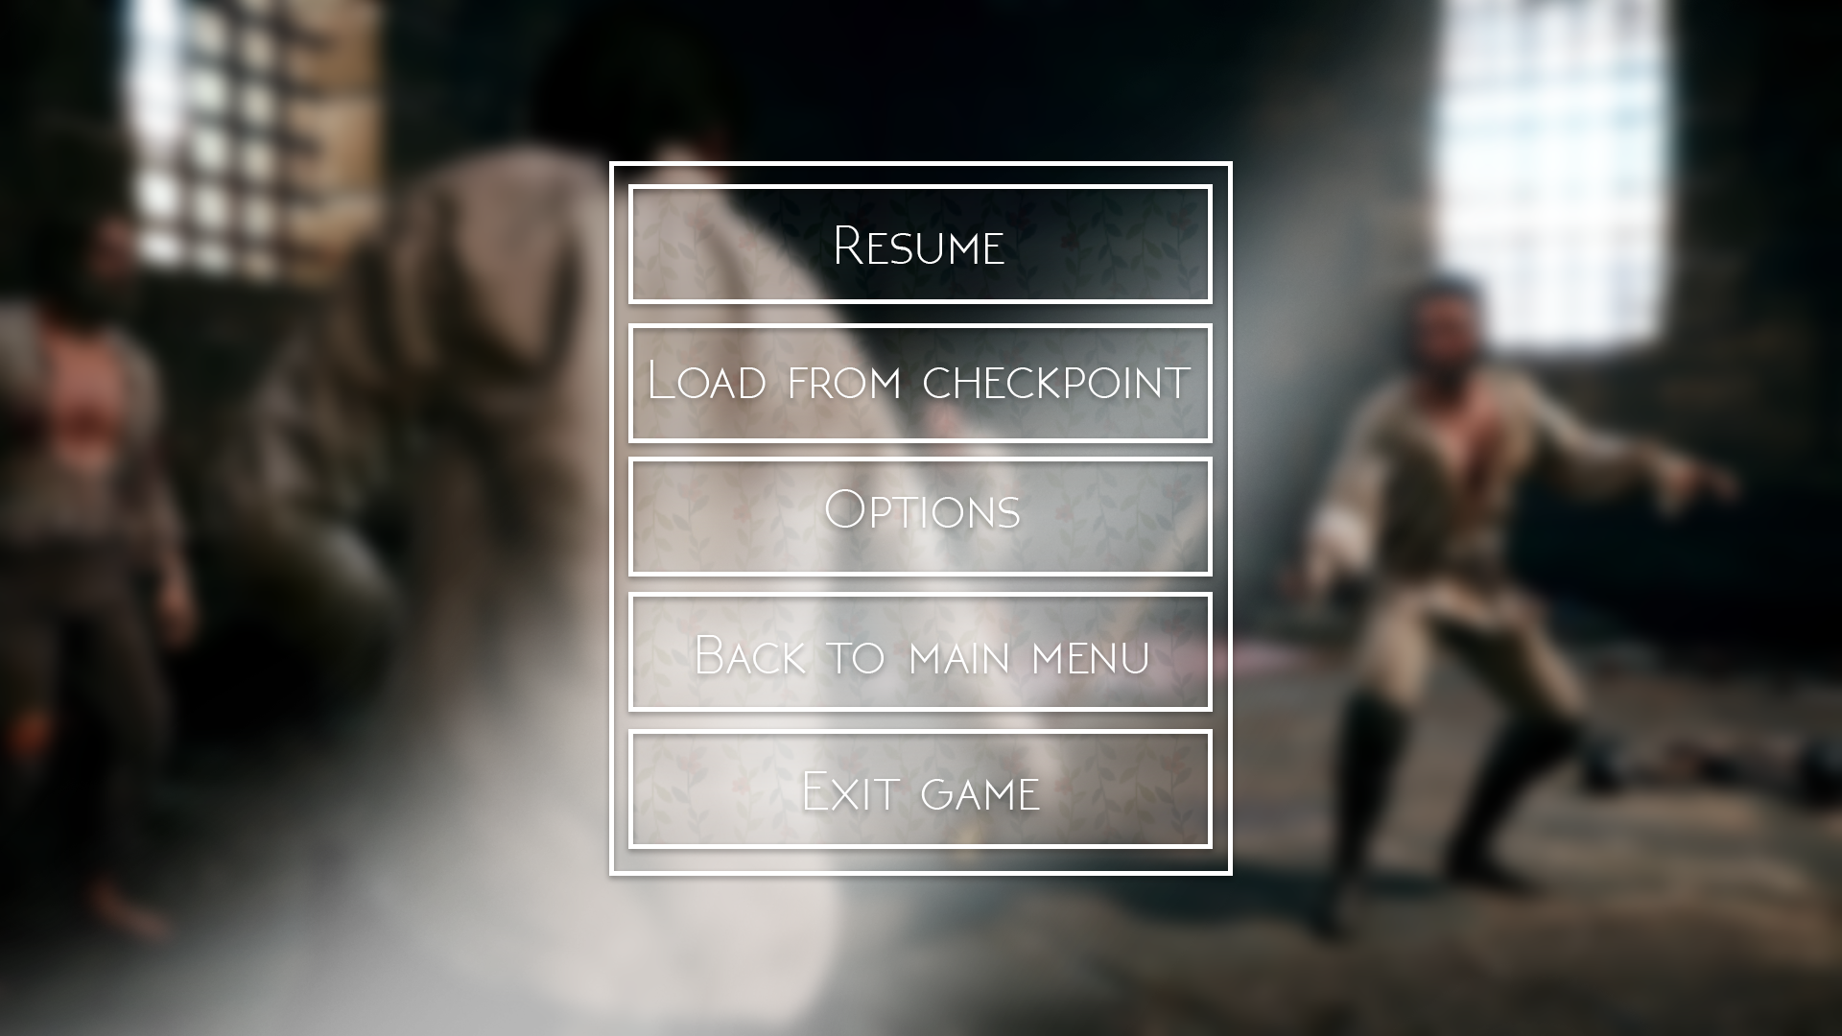

* Ingame menu Art
* HUD
  + - Health
    - Weapons
    - Abilities
    - Charge
* Inventory
  + - Extra weapons
* Quest log
  + - Current objective
    - History
* Map
  + - Objective marker
* Loading Screen

Resource Budget

* Resource budget
  + Prop polycount
    - Character 10000 poly
  + Texture resolution
  + Environment detail

Procedural / Modular Assets

We dont have a lot of modular assets we currently anticipate. Buildings will all be modeled as one piece.

The only pieces we will make modular are objects like fences, walls and other objects of that type.

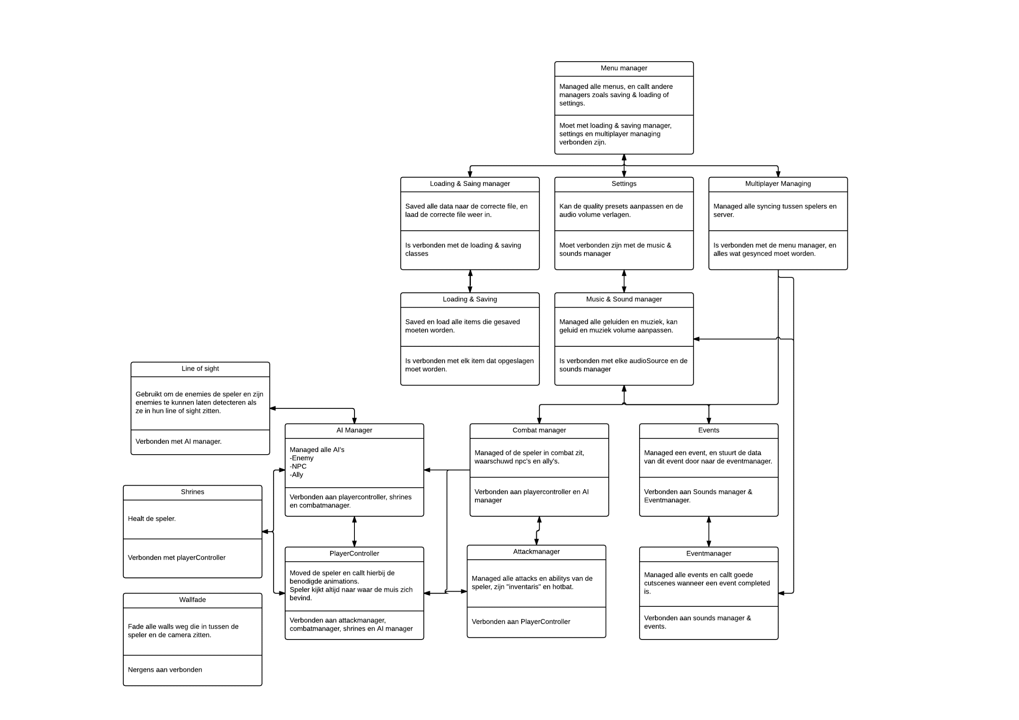UML Chart

The uml is somewhat smaller because I only noted all the systems. I cannot predict how many scripts I’m going to need in the final game.

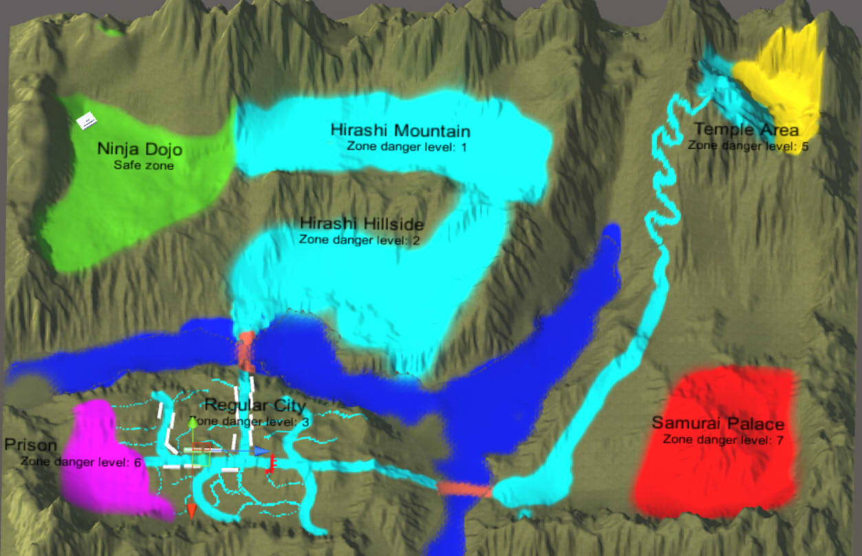Game Map

-Game map concept door René.

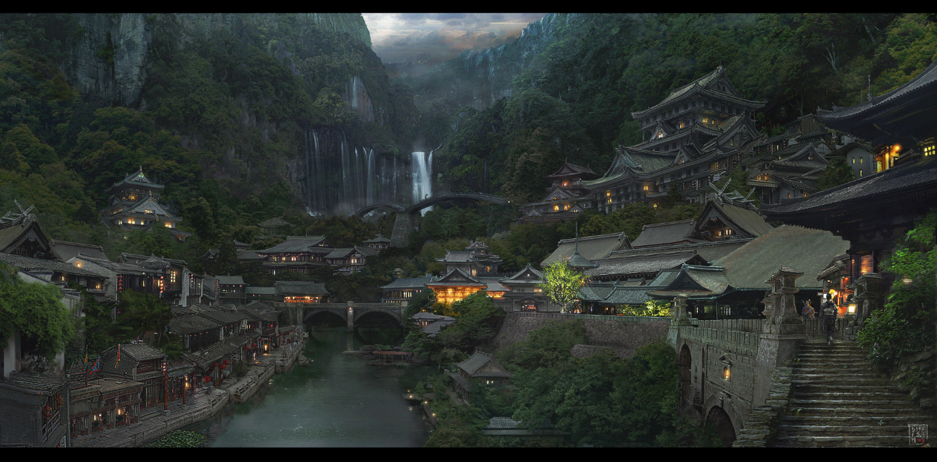Reference Material

* City style. This is the feeling we want to recreate in the city.

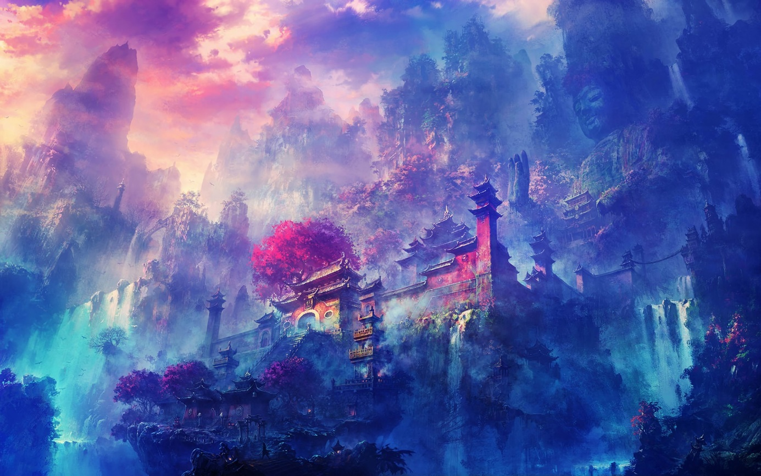

* Underworld Style 1.

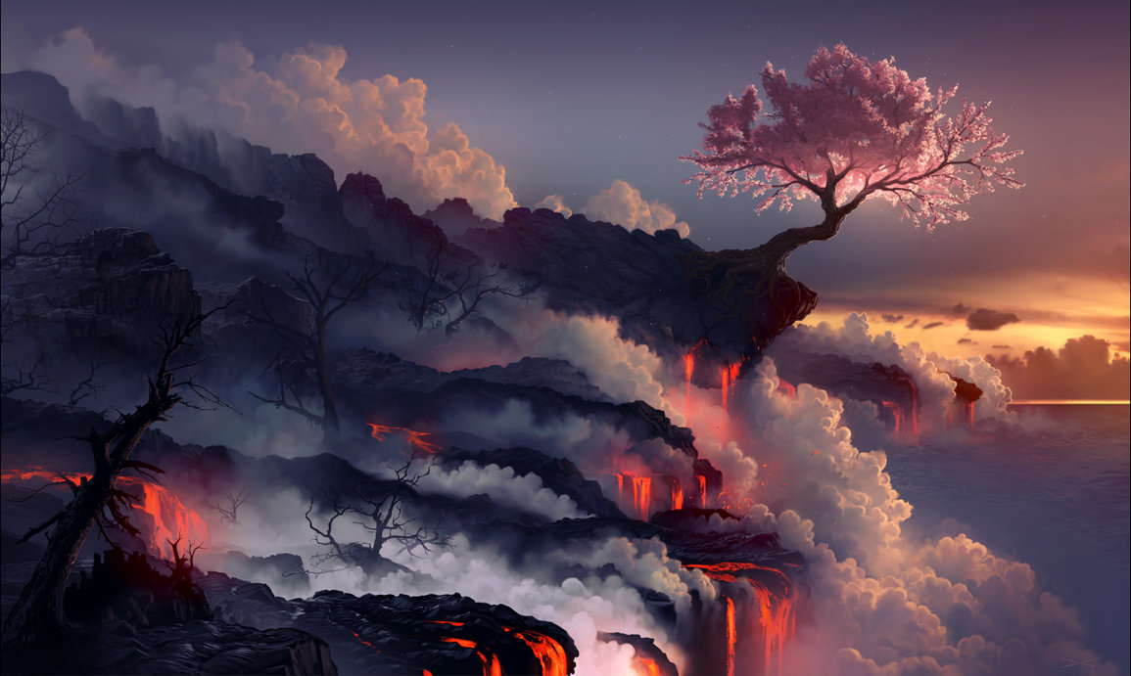

* Underworld style 2.